Customer Behavior Dictates Retailer’s Actions
In today’s retail environment, customers clearly have the upper hand. They decide when they enter or exit your store, how they research purchases, and when they buy. And, in the ubiquity of mobile devices, they choose when to launch your store’s mobile application, and what to post on social media about you.
These interactions or events can reveal a lot to the retailer, who takes the time to understand the hidden customer journey. The retailer can in turn identify risks and opportunities and then act accordingly.
In previous posts, we looked at IBM Operational Decision Manager Advanced (IBM ODM Advanced) with Decision Server Insights (DSI). DSI is the high-performance; highly available platform that provides real-time actionable insight capability to IBM ODM. This is accomplished by applying sophisticated business rules. IBM ODM Advanced with DSI can detect opportunities as soon as they occur—so you can quickly turn data into insight and make more accurate decisions.
Here’s how the business rules might work in the case of a shopper who is looking for an outfit to wear to a party.
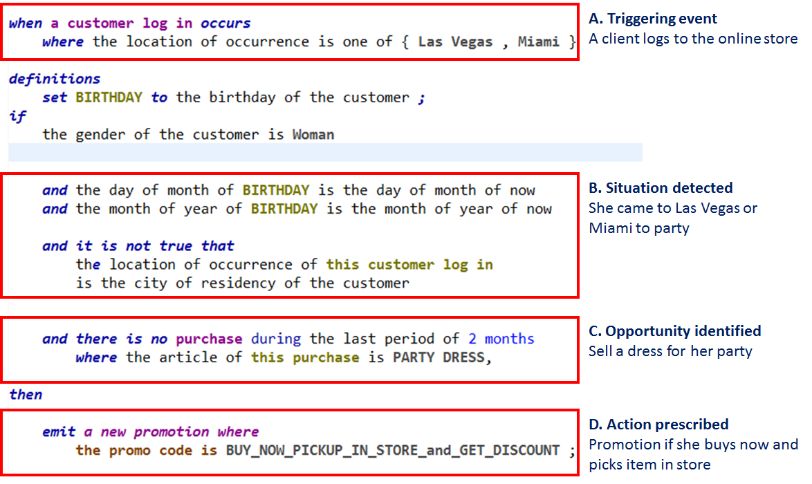
We see a similar pattern in all rules: a triggering event, a detected situation or anomaly, an opportunity or risk, and a proposed action to mitigate or take advantage of the situation. For example:
- Triggering event: Customer logs on to her favorite online retail store from Las Vegas.
- Situation detected: Customer profile shows today is her birthday and that she lives in Chicago. So, it is likely that she traveled to Las Vegas to celebrate her birthday.
- Risk or opportunity identified: Her recent purchase history does not show that she bought a dress she could wear for a party in Las Vegas. The retailer has an opportunity to sell one to her if she can receive it before the end of the day.
- Action to seize that opportunity: Same-day delivery is not available, so the store proposes that she buy online, visit the nearest store to pick it up, and get a 10 percent discount to compensate for the inconvenience.

What happens if an hour passes, and the customer does not respond?
In a second interaction, the triggering condition now becomes the absence of an event. And the focus is now on a risk instead of an opportunity.
- Triggering event: One hour lapsed and the customer did not purchase her dress.
- Situation detected: The customer seems uninterested.
- Risk identified: The customer may not buy a dress today.
- Action prescribed: A birthday greeting will be pushed to her mobile device, along with a 10 percent discount coupon, if she decides to buy today.
A third interaction is more advanced.
The customer finally decides to go to the store to get her dress. As she enters, an iBeacon (Apple low-energy indoor geolocation system) interacts with the mobile store app she launches. As a result:
- She is identified in the system.
- An event is sent to the DSI runtime.
- A seller receives a push notification identifying her as a high-value client, which prompts the seller to offer assistance and stay close by.

How does DSI know that she is a high-value client? The context of each customer record holds the amount he or she usually spends. DSI continuously averages, in real-time, “the amount usually spent” across all customers in a global aggregate. A customer who spends significantly more than the global aggregate is considered an outlier and an expensive, non-scalable, resource is assigned to him or her. The DSI rule language is accessible to both the IT and line of business departments for use in developing data-driven insights.
In our next blog post, we’ll take a closer look at how IBM ODM Advanced with DSI is transforming business into another industry.

